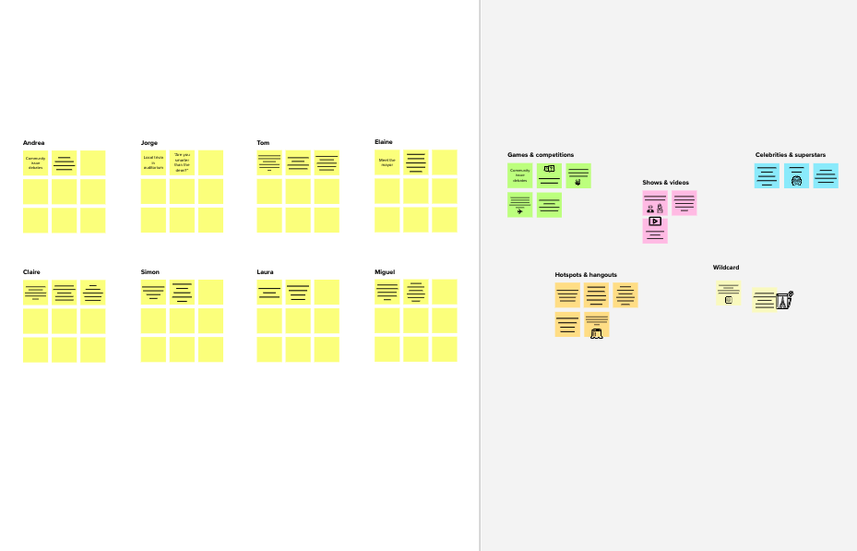

**Template**

Brainstorm

& idea prioritization

Use this template in your own brainstorming sessions so your team can unleash their imagination and start shaping concepts even if you're not sitting in the same room.

**10 minutes** to prepare

**1 hour** to collaborate

**2-8 people** recommended

**Share template feedback**

**Need some inspiration?**

See a finished version of this template to kickstart your work.

**Open example**

# Before you collaborate



## A little bit of preparation goes a long way with this session. Here’s what you need to do to get going.

**10 minutes**

1. **Team gathering**

Define who should participate in the session and send an invite. Share relevant information or pre-work ahead.

1. **Set the goal**

Think about the problem you'll be focusing on solving in the brainstorming session.

#### Learn how to use the facilitation tools

Use the Facilitation Superpowers to run a happy and productive session.

**Open article**

**1**



# Define your problem statement

## Solving the complaints of the customer through live chat.

**5 minutes**

**PROBLEM**

We know the customer complaints through tickets in the websites.

**Key rules of brainstorming**

To run an smooth and productive session

Stay in topic. Differ judgment.

Encourage wild ideas. Listen to others.

Go for volume. If possible, be visual.

**2**

# Brainstorm

## Write down any ideas that come to mind that address your problem statement.

**10 minutes**

#### Santhosh.K

**Naresh kumar.D**

#### Sathishkumar.P

**Yogesh kumar.K**



Implement support ticket tagging automation using AI.

Implement a website- based Chabot system.

Implementing a website based one on one Chat Forum.

Create a knowledge base or a self-service hub.

**3**



# Group ideas

## Take turns sharing your ideas while clustering similar or related notes as you go. Once all sticky notes have been grouped, give each cluster a sentence-like label. If a cluster is bigger than six sticky notes, try and see if you and break it up into smaller sub-groups.

**20 minutes**

Expand your customer service channels

Tackle data silos by automating distribution of support ticket insights

**4**



# Prioritize

## Your team should all be on the same page about what's important moving forward. Place your ideas on this grid to determine which ideas are important and which are feasible.

**20 minutes**

Implement support ticket tagging automation using AI.

Implementing a website based one on one Chat Forum.

**Importance**

Implement a website- based Chabot system.

If each of these tasks could get done without any difficulty or cost, which would have the most positive impact?

Create a knowledge base or a self-service hub.

**Feasibility**

Regardless of their importance, which tasks are more feasible than others? (Cost, time, effort, complexity, etc.)

# After you collaborate



You can export the mural as an image or pdf to share with members of your company who might find it helpful.

**Quick add-ons**

#### Share the mural

**Share a view link** to the mural with stakeholders to keep them in the loop about the outcomes of the session.

#### Export the mural

Export a copy of the mural as a PNG or PDF to attach to emails, include in slides, or save in your drive.

**Keep moving forward**

#### Strategy blueprint

Define the components of a new idea or strategy.

**Open the template**

#### Customer experience journey map

Understand customer needs, motivations, and obstacles for an experience.

### Open the template

#### Strengths, weaknesses, opportunities & threats

Identify strengths, weaknesses, opportunities, and threats (SWOT) to develop a plan.

### Open the template

**Share template feedback**